**Factorizing quadratic expressions**

When you start learning about algebra you are introduced to quadratic expressions. To simplify algebraic expressions and understand the various characteristics of quadratic functions factorization is a useful technique. Let’s dive into how to factorize quadratic expressions.

**Identifying a quadratic expression**

A quadratic expression is a polynomial where the highest power of the variable/unknown is 2.

Challenge:

Which of the following are quadratic expressions?

$x^{2} + 5x -3$

$-11a - 13a^{2} + 2$

$-5a^{3} + 20a^{2}$

${16a}^{2} -9$

$ay^{2} + 2ay + 19$

From the above expression 1, 2, 4, and 5 are all quadratic expressions. Expression 3 is cubic as the highest power of the variable (a) is 3.

**Factorizing quadratic expressions**

Factorizing an expression is about rewriting an expression as a product of one or more expressions. In quadratic expressions we are looking to convert expressions of the form $ax^{2} + bx +d$ into the following form:

$a(x+m)(x+n)$

To do this we can utilize the **ac** method.

**The ac method**

Consider the example ${2x}^{2} -7x +6$

Step 1: Identify the coefficients a,b, and c

a is the coefficient of $x^{2}$, therefore a = 2

b is the coefficient of x, therefore b = -7

c is the constant term, therefore c = 6

Step 2: Determine ac

$ac = 2×6$

ac = 12

Step 3: Select the suitable factor pair of **ac**

Here we need to consider the factor pairs of -12, which can be used to rewrite the middle term.

The factor pairs of -12 are:



$12 ×1$

$-12 ×-1$

$-6 × -2$

$6 × 2$

$3 ×4$

$-3 × -4$

Out of these, we need to pick the factor pairs of which the sum is equivalent to -7 (b). The factor -3 and -4 should be selected as -3 + -4 = -7.

Step 4: Rewrite the middle term as a sum of the selected factor pair

${2x}^{2} - 7x +6 = {2x}^{2} -3x + -4x + 6$

Step 5: Factorize in pairs

Now that we have broken down the quadratic expression into 4 terms, we can factorize in pairs, as shown below.

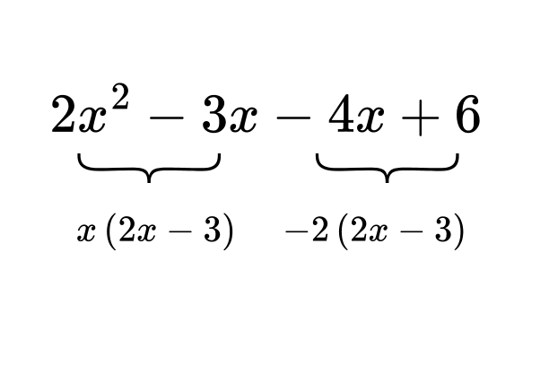

To factorize we select the common factor out of each expression:

$x(2x-3) -2(2x-3)$

Step 6: Factorize fully

We can see that (2x-3) is a common factor hence we can rearrange the expression as:

(2x-3)(x-2)

**Special Quadratic Expressions**

1. Difference of squares

The difference of squares is a special form of quadratic expressions. It takes the form:

$a^{2}-b^{2}$

This can be factored into:

$(a-b)(a+b)$

Example: Factorize $x^{2}-16$

This can be recognized as the difference of squares : $x^{2} - 4^{2}$

Therefore it can be factored as : $(x-4)(x+4)$

1. c = 0

When a quadratic expression has the form $ax^{2}+bx$, where there is no term independent of x, it can be factored as follows:

$x(ax+b)$

Example: Factorize ${14x}^{2}-21x$

This can be factored in by identifying the common factors : $7x(x-3)$